BL-K3 Brushless DC Controller (DC24~48V) User Manual
-  Precautions
- The 0V (negative pole) of the driver card power supply is grounded
- Before powering on, please make sure the positive and negative poles of the driver card power supply are connected correctly.
- Do not use in explosive environments, flammable gas environments, corrosive environments, places exposed to water, or near flammable materials.
- Do not touch the connection terminals of the driver card immediately after turning off the power (within 30 seconds), as residual voltage may cause electric shock.
- When setting up, connecting, running, operating, checking, and troubleshooting, all operations must be performed by qualified personnel.
- Please do not move, set up, connect, check, etc. when the power is on. When operating, be sure to cut off the power before operating.
Environmental requirements: Indoor (no direct sunlight, rain, water droplets, condensation and corrosive gas))
Usage Environment
Main Features
- Constant speed, start and stop, forward and reverse
- Analog/PWM and IO control
- Acceleration/deceleration time adjustment
- Overvoltage/undervoltage/overcurrent protection
- Multiple LED alarm indicators
Operating ambient temperature | -10-40℃
Operating environment humidity | 10%-90%RH (no frost)

Electrical parameters
 | Numerical | default value | unit
Current | < 10 | 5 | A
Pole pairs | --- | 4 | ---
Acceleration and deceleration | 10-3000 | 50 | ms
Applicable speed | --- | 3000 | RPM

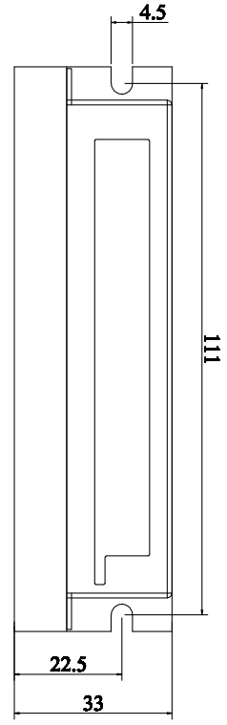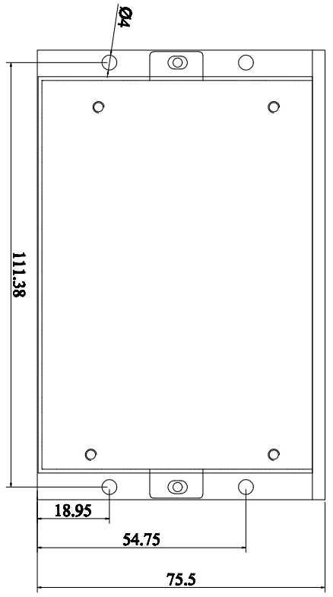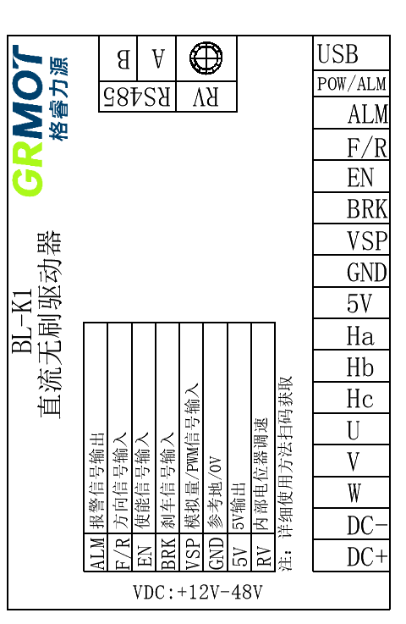Dimensions

Interface Function
Features and functions |  |  | Remark
powered by | Voltage | Normal operating voltage 24-48V
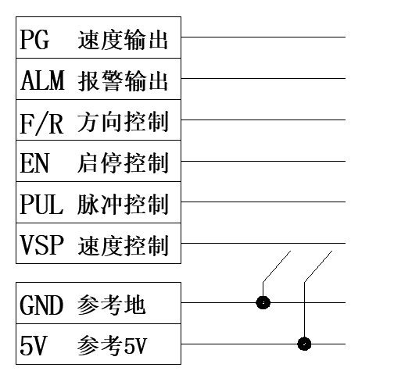 |  | - Start and stop control: connect 5V or disconnect to control running or stopping  - Direction control: connect 5V or disconnect to control forward or reverse  - Speed ​​control: When SW3=OFF, select VSP and PUL speed regulation  When SW3= ON, select internal RV potentiometer speed control  - Status indication: Controller abnormal ALM alarm 5V output  The indicator lights flash alternately (see the attached table for details)

Wiring Diagram
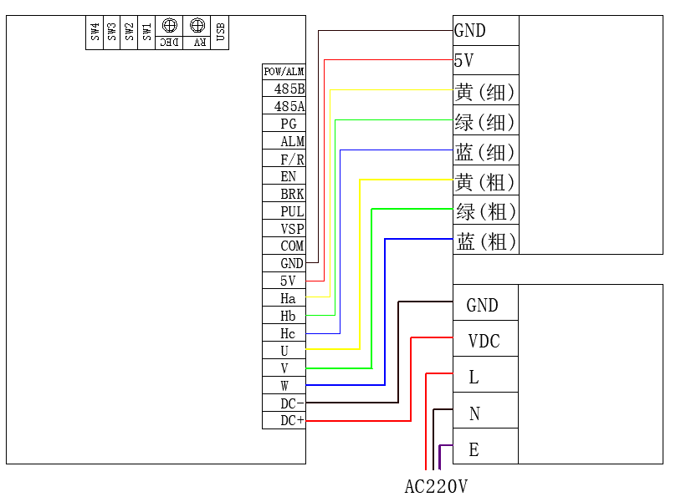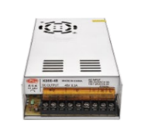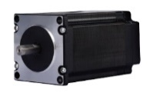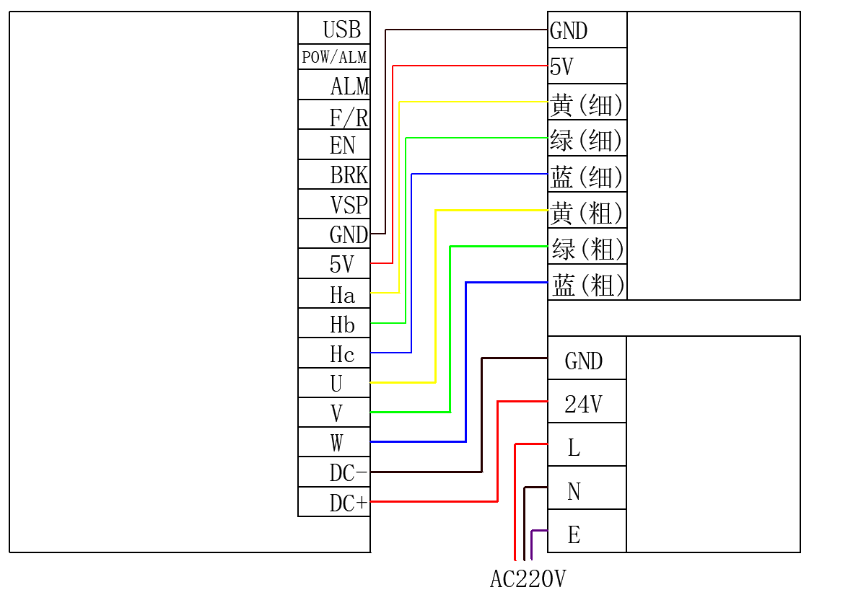
24-48V power supply
brushless motor

Dip switch function
DIP status |  |  |  | Functional Mode | Remark
SW1 | SW2 | SW3 | SW4 | Functional Mode | Remark
ON | OFF | ----- | ----- | Closed loop 2-stage | Closed loop 2-pair motor operation
OFF | ON | ----- | ----- | Closed loop 4 pairs | Closed loop 4-pair motor operation
ON | ON | ----- | ----- | Closed loop 5 pairs | Closed loop 5-pair motor operation
OFF | OFF | ----- | ----- | Open-loop control | Open-loop operation
----- | ----- | OFF | ----- | Internal speed regulation | Driver internal potentiometer speed control
----- | ----- | ON | ----- | External speed regulation | Drive external terminal speed control
----- | ----- | ----- | OFF | DIP switch parameters | Internal dial control motor parameters
----- | ----- | ----- | ON | Debugging parameters | External communication control motor parameters

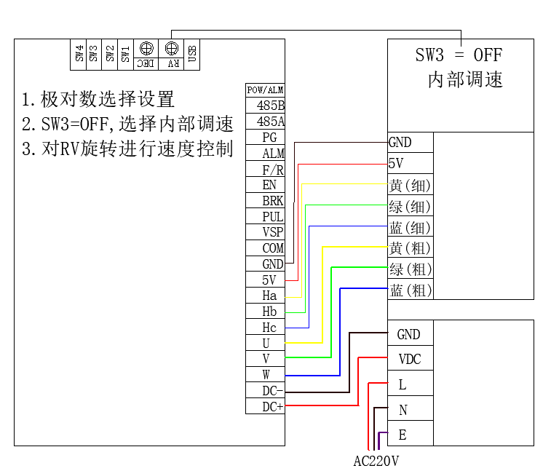Use internal speed control
When SW3 = OFF, select the internal potentiometer RV for speed control. Rotate the potentiometer RV to control. The maximum speed of the driver is 3000rpm by default. Here, the maximum speed and other modifications can be made by turning SW4 = ON to modify the motor parameters.

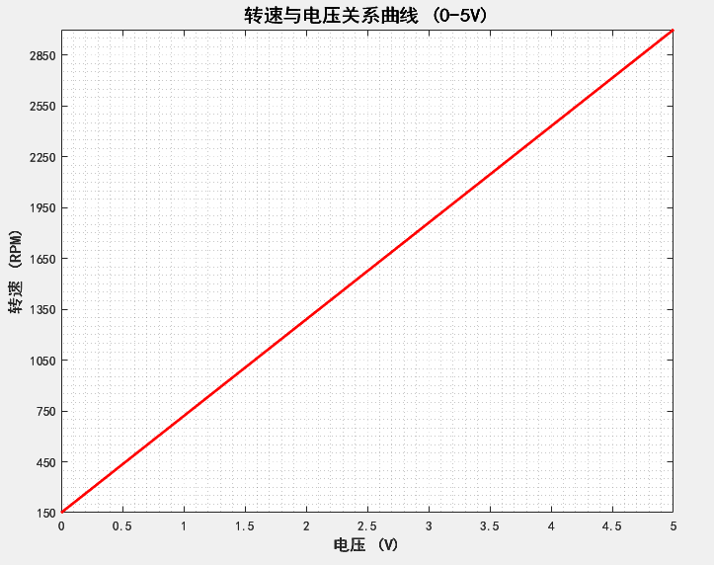Use external speed control (Analog speed regulation DC (0~5V))
When SW3 = ON, the external analog is connected to the VSP terminal, and the PUL terminal is left floating. An external potentiometer is required (VCC is connected to 5V, GND is connected to COM or GND) or a 0-5V analog is connected. The factory default maximum speed of the driver is 3000rpm. Here, the maximum speed and other modifications can be made by turning SW4 = ON to modify the motor parameters.
The right picture is the curve of a certain external analog speed regulation linearity test

Use external speed control (duty cycleSpeed ​​regulation)
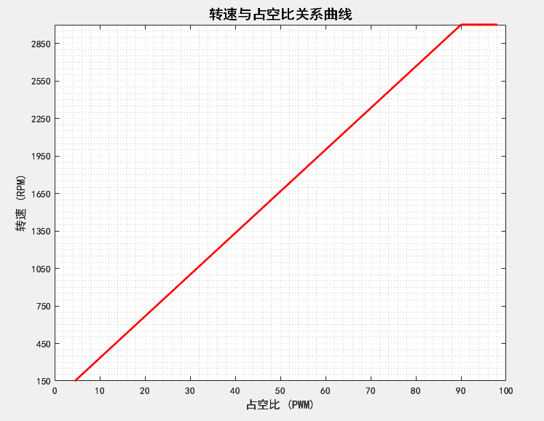
When SW3 = ON, the external duty cycle is connected to the VSP terminal, the PUL terminal is left floating, and the duty cycle control is used (square wave 5V, bias 2.5V, frequency 10-50KHZ). The factory default maximum speed of the driver is 3000rpm. Here, the maximum speed and other modifications can be made by turning SW4 = ON to modify the motor parameters.
The right figure is the curve of a certain external duty cycle speed regulation linearity test

Use external speed control (pulse frequencySpeed regulation)
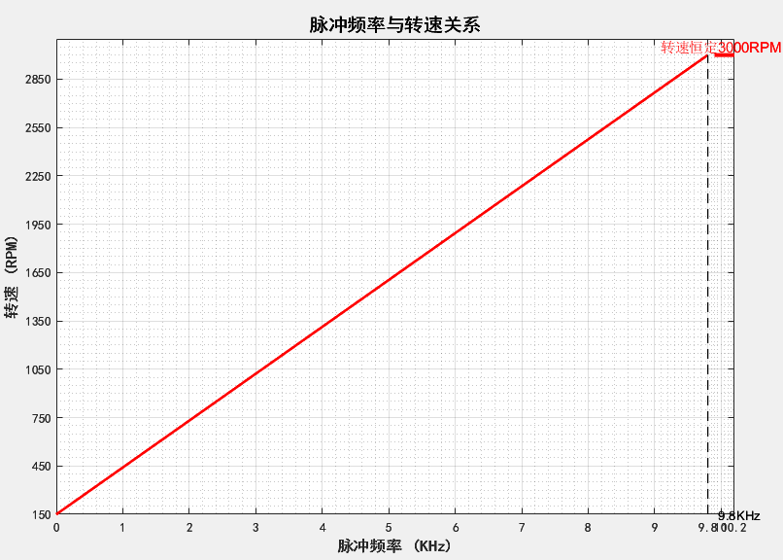
When SW3 = ON, the external pulse frequency is connected to the PUL terminal, the VSP terminal is left floating, and pulse frequency control is used (square wave 5V paranoid 2.5V, 0-10KHZ). The factory default maximum speed of the driver is 3000rpm. Here, the maximum speed and other modifications can be made by turning SW4 = ON to modify the motor parameters.
The right picture is the curve of a certain external pulse frequency speed regulation linearity test

The right figure is the curve of a certain external duty cycle speed regulation linearity test

Status indicator and abnormal handling
1 green 4 red | Driver voltage is too high | The power supply voltage is too high
1 green 5 red | Driver overcurrent | Motor wiring error or MOS short circuit
1 green 6 red | Motor open circuit | The motor power line is not connected properly
2 green 3 red | Internal voltage error | Driver internal circuit failure
2 green 4 red | Driver voltage is too low | The supply voltage is lower than 15VDC
2 green 5 red | Motor overload | External load is too large
2 green 6 red | Hall signal error | Hall signal line is not connected properly
1 green 7 red | Communication Error | The communication line is not connected properly

